Chemistry 141 Exam 2a Name
Martin Larter March 16, 2016

Multiple Choice (30 points)
Page 5 (14 points)
Page 6 (18 points)
Page 7 (12 points)
Page 8 (20 points)
Page 9 (10 points)
Total (104 points)
All work must be shown to receive credit. Give all answers to the correct number of significant figures

Chemistry Formula
Kinetic energy = ½ mv²
w = -PΔV
P_{total} = P₁+P₂+P₃+…
u = (3RT/MW)^{½}
ΔG = ΔH - TΔS
PV = nRT
Rate ∝ (MW)^{-½}
P₁=X₁*P_{total}
C = q/ΔT
P_{total} = P₁ + P₂ + P₃ + …
M = mol/L
K = ºC + 273.16
w=dxF
E = mc²
$$E=nhν$$
$$c=λν$$
M₁V₁ = M₂V₂
P_{total} = P₁ + P₂ + P₃ + …
M = mol/L
$$\frac{{Rate}_{1}}{{Rate}_{2}}=\sqrt{\frac{{MW}_{2}}{{MW}_{1}}}$$
$$\left(P+\frac{n^{2}a}{V^{2}}\right)\left(V-nb\right)=nRT$$
$$λ_{deBroglie}=\frac{h}{mv}$$
Constants
Avogadro’s number = 6.022 x 10²³ /mol
Density of H₂O(l) = 1.00 g/mL
h = 6.626 x 10⁻³⁴ J sec
c= 2.9979 x 10⁸ m/sec
e = 1.602 x 10⁻¹⁹ C
K = ºC + 273.16
1 kcal = 4.184 kJ
R = 0.0821 L atm/mol K = 62.4 L torr/mol K = 8.31 kJ/mol K
760 torr = 760 mm Hg = 1.00 atm = 101 kPa = 14.6 psi = 30 in Hg
Heats of formation of compounds
Compound | ΔHº_{f} (kcal mol⁻¹)
H⁺(aq), proton | 0.0
Na⁺(aq), sodium ion | -57.28
NaF(s), sodium fluoride | -136.0
NaCl(s), sodium chloride | -98.23
NaBr(s), sodium bromide | -86.03
NaI(s), sodium iodide | -68.84
C(s), diamond | 0.453
CO₂(g), carbon dioxide | -94.05
C₆H₆(g), benzene | 19.82
CH₃OH(g), methanol | -48.10
C₂H₅OH(g), ethanol | -56.27
C₂H₅OH(l), ethanol | -66.35
NH₃(g), ammonia | -11.04
NH₃(aq), ammonia | -19.32
NH₄⁺(aq), ammonium ion | -31.74
NH₄Cl(s), ammonium chloride | -75.38
OH⁻(aq), hydroxide ion | -54.96
H₂O(g), water | -57.80
H₂O(l), water | -68.32
F⁻(aq), fluoride ion | -78.66
HF(g), hydrogen fluoride | -64.20
Cl⁻(aq), chloride ion | -40.02
HCl(g), hydrogen chloride | -22.06
HCl(aq), hydrogen chloride | -40.02
Br⁻(aq), bromide ion | -28.90
I⁻(aq), iodide ion | -13.37

Grossmont College
Periodic Table
IA |  |  |  |  |  |  |  |  |  |  |  |  |  |  |  |  | VIIA | NOBLE GASES
1  H  1.008 | IIA |  |  |  |  |  |  |  |  |  |  |  | IIIA | IVA | VA | VIA | 1  H  1.008 | 2  He  4.002
3  Li  6.941 | 4  Be  9.012 |  |  |  |  |  |  |  |  |  |  |  | 5  B  10.81 | 6  C  12.01 | 7  N  14.01 | 8  O  16.00 | 9  F  19.00 | 10  Ne  20.18
11  Na  23.00 | 12  Mg  24.30 | IIIB | IVB | VB | VIB | VIIB | VIII VIII VIII |  |  |  | IB | IIB | 13  Al  27.00 | 14  Si  28.09 | 15  P  30.97 | 16  S  32.06 | 17  Cl  35.45 | 18  Ar  39.95
19  K  39.10 | 20  Ca  40.08 | 21  Sc  44.96 | 22  Ti  47.90 | 23  V  50.94 | 24  Cr  52.00 | 25  Mn  54.94 | 26  Fe  55.85 | 27  Co  58.93 | 28  Ni  58.70 |  | 29  Cu  63.55 | 30  Zn  65.38 | 31  Ga  69.72 | 32  Ge  72.59 | 33  As  74.92 | 34  Se  78.96 | 35  Br  79.90 | 36  Kr  83.80
37  Rb  85.47 | 38  Sr  87.62 | 39  Y  88.91 | 40  Zr  91.22 | 41  Nb  92.91 | 42  Mo  95.94 | 43  Tc  (99) | 44  Ru  101.1 | 45  Rh  102.9 | 46  Pd  106.4 | 47  Ag  107.9 |  | 48  Cd  112.4 | 49  In  114.8 | 50  Sn  118.7 | 51  Sb  121.8 | 52  Te  127.6 | 53  I  126.9 | 54  Xe  131.3
55  Cs  132.9 | 56  Ba  137.3 | 57  La  138.9 | 72  Hf  178.5 | 73  Ta  180.9 | 74  W  183.9 | 75  Re  186.2 | 76  Os  190.2 | 77  Ir  192.2 | 78  Pt  195.1 | 79  Au  197.0 |  | 80  Hg  200.6 | 81  Tl  204.4 | 82  Pb  207.2 | 83  Bi  209.0 | 84  Po  (209) | 85  At  (210) | 86  Rn  (222)
87  Fr  (223) | 88  Ra  226.0 | 89  Ac  227.0 | 104  Rf  (261) | 105  Db  (262) | 106  Sg  (263) | 107  Bh  (262) | 108  Hs  (265) | 109  Mt  (266) | 110  ??  (269)

58  Ce  140.1 | 59  Pr  140.9 | 60  Nd  144.2 | 61  Pm  (147) | 62  Sm  150.4 | 63  Eu  152.0 | 64  Gd  157.3 | 65  Tb  158.9 | 66  Dy  162.5 | 67  Ho  164.9 | 68  Er  167.3 | 69  Tm  168.9 | 70  Yb  173.0 | 71  Lu  175.0
90  Th  232.0 | 91  Pa  231.0 | 92  U  238.0 | 93  Np  (237) | 94  Pu  (244) | 95  Am  (243) | 96  Cm  (247) | 97  Bk  (247) | 98  Cf  (251) | 99  Es  (252) | 100  Fm  (257) | 101  Md  (258) | 102  No  (259) | 103  Lr  (260)

Lanthanide series

Actinide series

Multiple Choice (30 points) – Give the best answer for each of the following questions.

- The following diagrams illustrate the flow of energy (q) and work (w) in different processes. Which one is definitely an exothermic process?
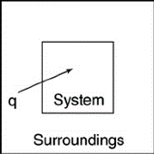
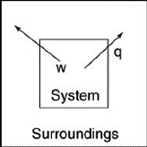
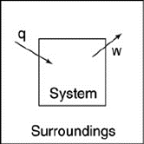
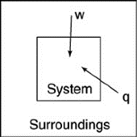

a. b. c. d.

- Which of the following bar charts shows the correct internal energy changes that occur when a propane grill is used to cook a steak? (Consider the propane combustion reaction to be the system. Consider the grill, steak, and everything else to be the surroundings.)
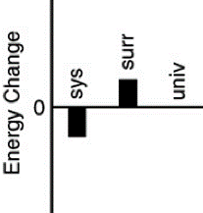
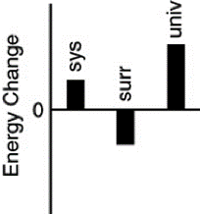
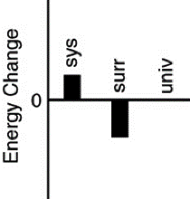
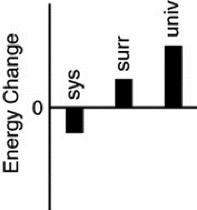

a. b. c. d.

- For the following balanced redox reaction identify the reducing agent

                - 4 HCl(aq) + Hg₂Cl₂(s) + 2 KNO₂(aq) 2 HgCl₂(aq) + 2 NO(g) + 2 KCl(aq) +2 H₂O(l)

- KNO₂(aq) | - HgCl₂(aq) | - NO(g) | - Hg₂Cl₂(s) | - KCl(aq)

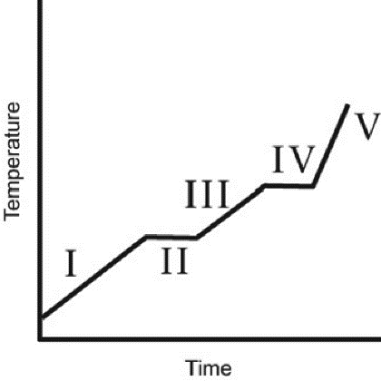
- The heating curve for a substance is shown to the right. The substance initially is a solid. It then becomes a liquid and a gas. Which of the line segments (I–V) represents the solid to liquid phase transition?

  - I
  - II
  - III
  - IV
  - V

- You hold a 50 g sphere of copper in one hand and a 25 g sphere of aluminum in the other hand. If both absorb energy at the same rate, which will come to your body temperature first and why? The specific heat capacities are 0.4 J/(g °C) for copper and 0.9 J/(g °C) for aluminum.
  - copper, because the specific heat is smaller
  - aluminum, because the specific heat is larger
  - aluminum, because the mass is smaller
  - copper, because the heat capacity is smaller
  - Both reach body temperature at the same time because they absorb energy at the same rate.

- In which one of the following compounds is the oxidation number of S equal to +4?
- H₂S | - S₈ | - S₂Cl₂ | - Na₂SO₃ | - MgSO₄
- A 15 g piece of iron (C_{P} = 25.09 J/(mol · °C)) is heated to a temperature of 95°C and placed into a bucket containing 4.5 gal of water (C_{P} = 75.38 J/(mol · °C)) initially at 25°C. Eventually,
  - the water will be warmer than the iron.
  - the iron will be warmer than the water.
  - the iron will be colder than the water.
  - the iron and the water will be at the same temperature.
  - the temperature will be the average of 95°C and 25°C.

- In terms of the enthalpy of formation, which of the following compounds is most stable relative to its elements under standard conditions?

  - PbBr₂(s), ΔH = –277.4 kJ/mol
  - H₂Se(g), ΔH = +29.7 kJ/mol
  - O₃(g), ΔH = +142.3 kJ/mol
  - ICl(g), ΔH = +17.8 kJ/mol
  - SO₂(g), ΔH = –269.9 kJ/mol

- Which statement about the properties of a gas is not correct?
  - Unlike a solid or a liquid, gases expand to occupy the entire volume of their container.
  - When the temperature is changed, the volume of gas changes much more than the volume of a solid or liquid.
  - Different gases are completely miscible with each other.
  - The density of a gas typically is much larger than the density of a solid or liquid.
  - When the pressure is changed, the volume of a gas changes much more than the volume of a solid or liquid.

- A soft drink rises in a straw when you suck on the straw because ________
  - the vacuum pulls the liquid up the straw.
  - capillary forces attract the liquid to the walls of the straw.
  - the air pressure inside the straw is less than the air pressure outside the straw.
  - the air pressure inside the straw is greater than the air pressure outside the straw.
  - the liquid level inside the straw is pushed up by the liquid level outside the straw.
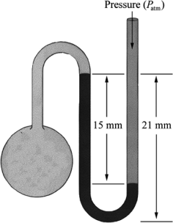
- What is the pressure in the gas bulb connected to the mercury manometer shown in the diagram if the ambient pressure is 750 torr? The heights labeled in the diagram are 15 mm and 21 mm.
  - 756 torr
  - 765 torr
  - 771 torr
  - 735 torr
  - 729 torr

- Which statement A–D regarding an ideal gas is not correct?
  - The volume occupied by an individual molecule is negligible.
  - No interactions occur between molecules other than hard sphere collisions.
  - Molecules move in random directions and collide with each other.
  - The volume occupied by 1 mol of molecules at STP is 22.4 L.
  - Statements A–D all are correct.

- The partial pressure of a gas is ________
  - The pressure the gas exerts when pure.
  - The same as the vapor pressure of the gas.
  - The pressure due to the gas in a mixture.
  - The total pressure of a mixture of gases.
  - The pressure exerted by one molecule of the gas.
- A mixture of 1.0 mol He and 1.0 mol Ne are at STP in a rigid container. Which of the following statements is TRUE?
  - Both gases contribute equally to the density of the mixture under these conditions.
  - Both gases have the same average kinetic energy.
  - Both gases have the same molecular speed.
  - The mixture has a volume of 22.4 L
  - All of the above are TRUE.

- Which of the following figures is the most accurate representation of a gas sample? The arrows show the velocities of individual molecules.
  - 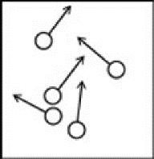 c. 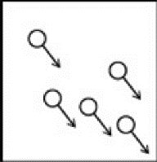
  - 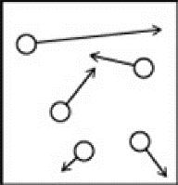 d. 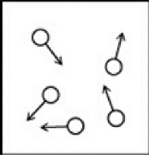

Problems

- (8 points) Balance the following redox reaction in basic solution

Fe(OH)₃ (aq) + OCl– (aq) FeO₄^{2–} (aq) + Cl– (aq)

Oxidation: _________________________________________________

Reduction: ___________________________________________________

Balanced Redox equation in base:

- (6 points) Assume that a particular reaction evolves 244 kJ of heat and that 35 kJ of work is done on the system. What are the values of ΔE and ΔH?

- (6 points) The flavor of anise is due to anethole, a compound with the molecular formula C₁₀H₁₂O. The ΔH_{rxn} for the combustion of anethole is −5541 kJ/mol. If 1.25 g if anethole is burned in a calorimeter with a heat capacity of 8.63 kJ/ºC with at a temperature of 22.144 ºC. What will the temperature of the calorimeter be at the end of the reaction?

- (8 points) Sulfuric acid (H₂SO₄), the most widely produced chemical in the world, is made by a two-step oxidation of sulfur to sulfur trioxide, SO₃, followed by reaction with water.
  - Write the equation that represents the heat of formation of SO₃(g)

__________________________________________________________

  - Given the data below, calculate the ΔHº_{f} of sulfur trioxide gas.

SO₂(g) S(s) + O₂(g) ΔHº = + 296.8 kJ
2 SO₂(g) + O₂(g) 2 SO₃(g) ΔHº = − 197.8 kJ

- (4 points) Explain why real gases behave nonideally at low temperatures and high pressures.

- (6 points) Consider the reaction

2ClF₃(g) + 2 NH₃(g) N₂(g) + 6 HF(g) + Cl₂(g) ΔHº = − 1196 kJ

  - Calculate the ΔHº_{f} for ClF₃(g).

  - How many kJ of heat is produced when 5.00 g of ClF₃ reacts with excess ammonia using the equation above?

- (6 points) A small cylinder of helium gas used for filling balloons has a volume of 2.30 L and a pressure of 13,800 kPa at 25ºC.

  - What is the pressure of the cylinder in torr and atm?

  - How many balloons can you fill if each one has a volume of 1.5 L and a pressure of 1.25 atm at 25ºC?

- (6 points) Calculate the density in g/L of methane gas (CH₄) at a 35ºC and 861 torr.

- (6 points) A 50.0 mL flask is evacuated and contains nitrogen gas at a pressure of 3.7 torr and 25ºC. How many molecules of nitrogen are in the flask?

- (8 points) Phosphorous pentachloride decomposes to form phosphorus trichloride and chlorine gas as demonstrated in the following chemical equation:
PCl₅(g) PCl₃(g) + Cl₂(g)
A 5.00 L round bottom flask is filled with phosphorus pentachloride with a pressure of 2.85 atm. The vessel is heated to 1000K and after cooling back to the original temperature the new pressure is 3.41 atm. Calculate the partial pressure of all gases present at the end of the reaction.

- (6 points) It takes 56 s for a sample of N₂(g) to effuse through a tiny orifice. Determine the molar mass of a gas whose effusion time under exactly the same conditions is 83 s.

- (4 points) Why are the standard enthalpies of formation of elements in their standard states assigned a value of zero?

